SPYCAT Team Report

Team L2B-15: Arnold Ying, Rain Zhang, Stella Wang, Yisheng Liu

## Introduction

After experiencing social isolation for two years, our team was motivated to provide companionship virtually through our project. SPYCAT is a virtual pet system built on a De1-SoC FPGA board with integrated multiplayer components. It aims to improve the user’s quality of life by preventing loneliness or boredom through virtual interaction with other SPYCAT users. SPYCAT provides an immersive experience for users through a touchscreen UI, audio music, and motion detection.

Teens aged 14-18 were our main target group, so our project’s main requirements were ease of use, affordability and portability.

## Accomplishments

In our final SPYCAT product, we successfully implemented all features outlined in our project proposal. In terms of hardware components, we implemented the VGA, touchscreen, Wi-Fi, 3.5mm audio, and camera. In terms of software/cloud components, we implemented the leaderboard website, the node server backend, the motion detection script, the MongoDB database, and GUI (graphical user interface). We chose to use a USB webcam instead of the D8M GPIO camera, since there was not sufficient on-chip memory on one FPGA board to support image capture, and we needed to ensure portability requirements for our project were met.

## System Description

The frontend includes a graphical user interface that displays a virtual cat on a screen that users can pet by tapping it on the screen. Upon being pet, the cat becomes animated and sings a short song. The cat colours are customized with a name and colour when users sign in. The current local weather is also displayed beside the pet with an icon for different kinds of weather. The user is able to add and delete friends by username and friends can chat with each other and have playdates. Playdates consist of a mini game of rock, paper, scissors through which the winner gets one friendship point if they win. Additionally, there is a SPYCAT leaderboard website that users can visit to find out which SPYCAT users globally have the most friendship points.

The backend consists of a node express server hosted on an Amazon EC2 instance that the FPGA can communicate with through HTTP API requests

## Breakdown of Member Contributions

Our team spent the majority of our time working together in person to figure out hardware components and integration. Below are components that each member contributed the most to.

* Arnold worked on setting up the ESP8266 wifi module LUA scripts, writing the API helper C library, USB Webcam setup on Ubuntu, GPIO Camera hardware state machine, GUI logic to send/receive requests from our node server backend.
* Rain worked on set up our MongoDB database, configured the Amazon EC2 instance, helped with website UI, and designed the motion detection script
* Stella worked on flashing the ESP8366 wifi module, writing and uploading LUA scripts to the ESP8266, writing API functions in C, writing the the node express server endpoints and uploading that to EC2, setting up the qsys for audio, and the audio drivers in C
* Yisheng worked on integrating the USB Webcam, setting up the Serial controller and VGA touchscreen driver, built the GUI, and set up our leaderboard website

## Conclusions and Solution Assessment

All of our original project goals outlined in our proposal were achieved in our final product. We met the hardware component by incorporating various peripherals: VGA display, touchscreen, 3.5mm audio, and camera. The UI requirement was met through implementing features like keyboards and buttons on our touchscreen in our graphical UI interface. The cloud component was met through hosting our database on the cloud and our node server on EC2. The network component was met through sending HTTP requests over wifi connection. In general, the final SPYCAT system is robust as we fixed a majority of the bugs that we came across during our development and testing.

**Appendix**

**Appendix A - GUI**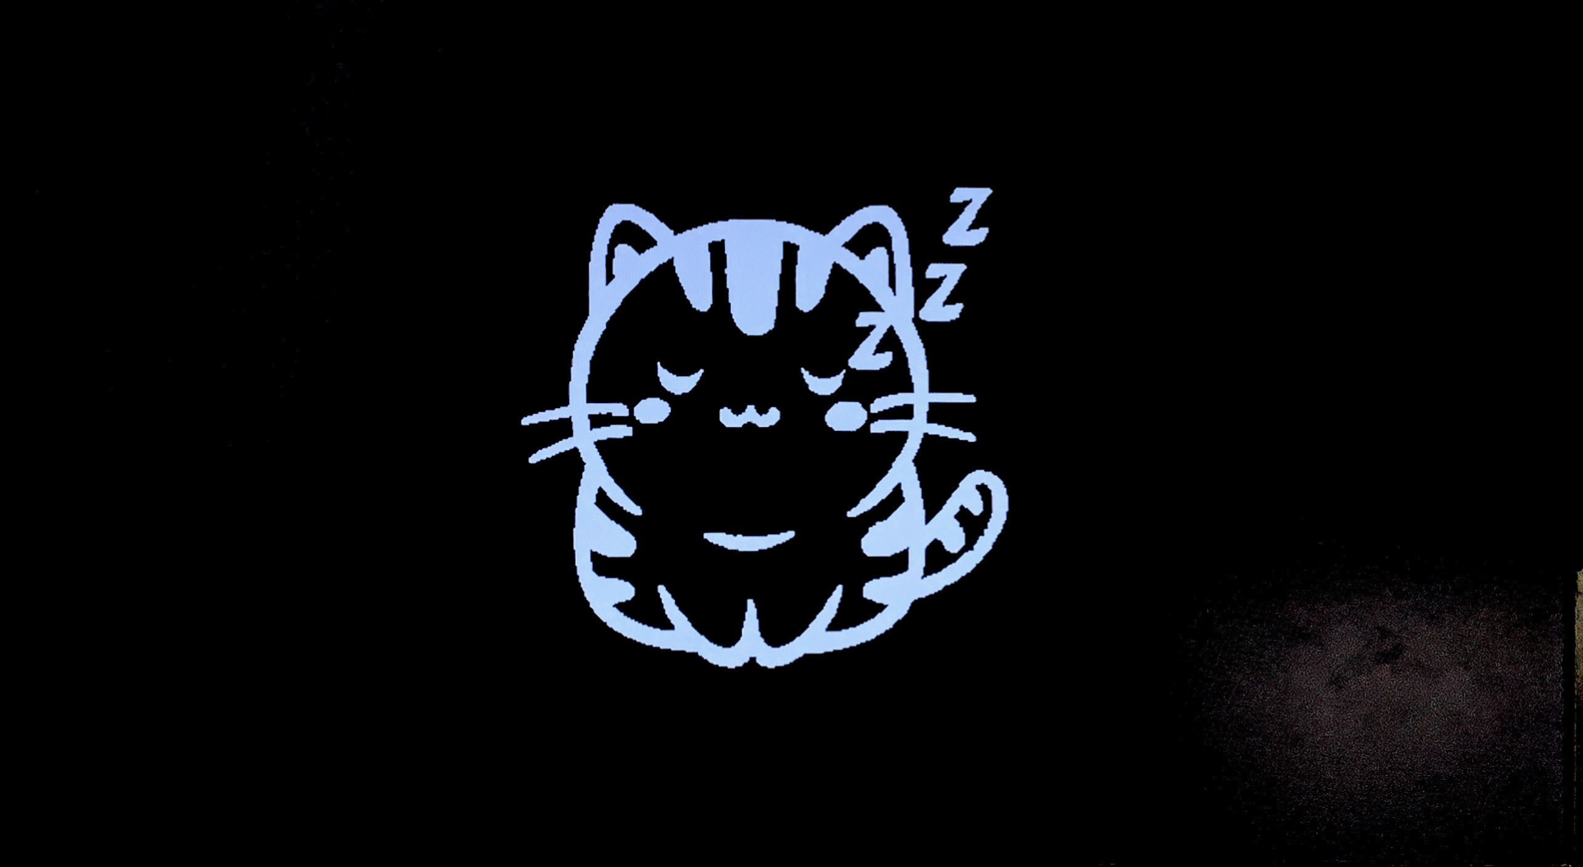

Figure A.1 - Screen of sleep toggle

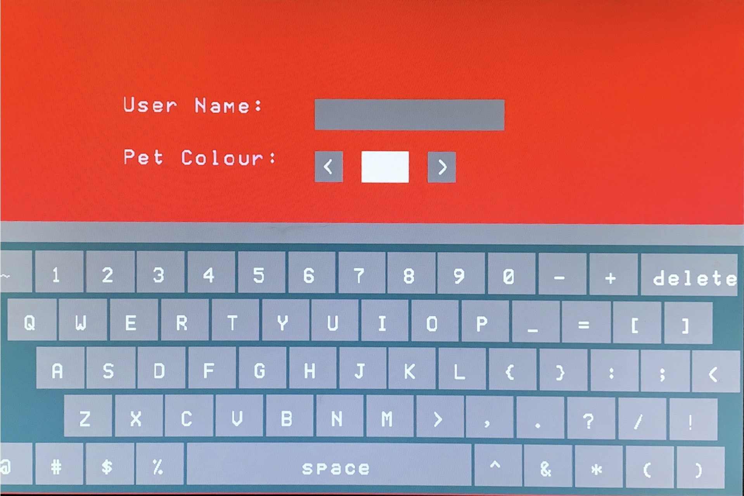

Figure A.2 - Screen of login screen

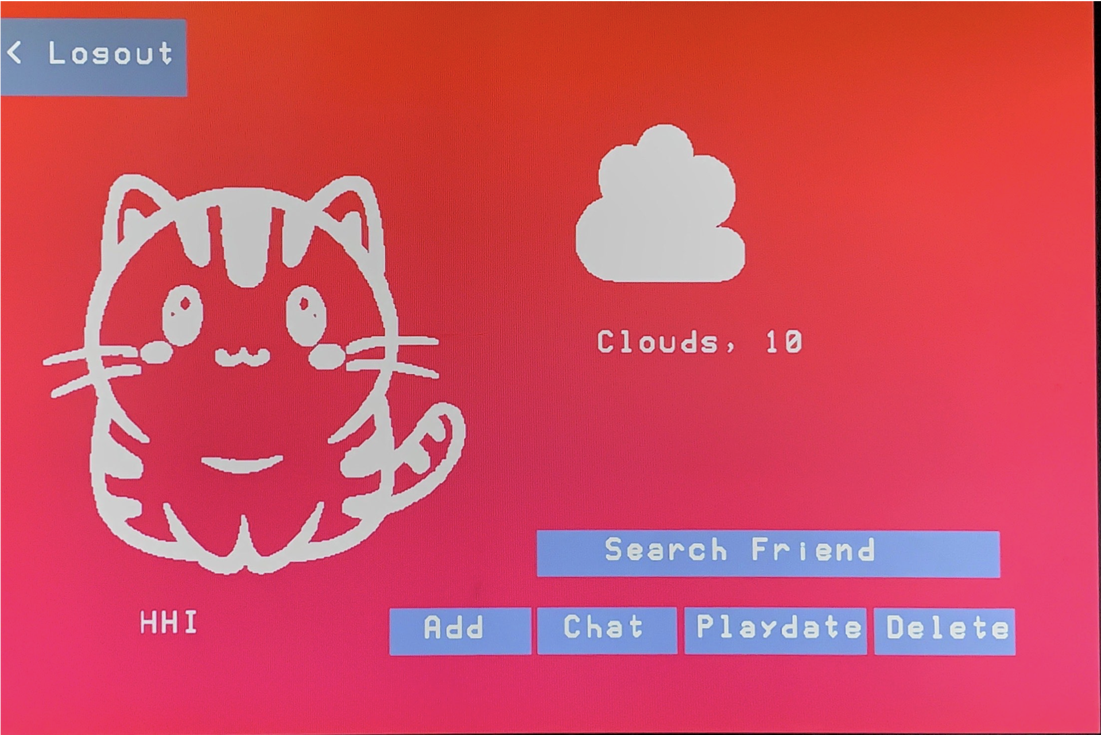

Figure A.3 - Screen of home screen showing weather and functional buttons

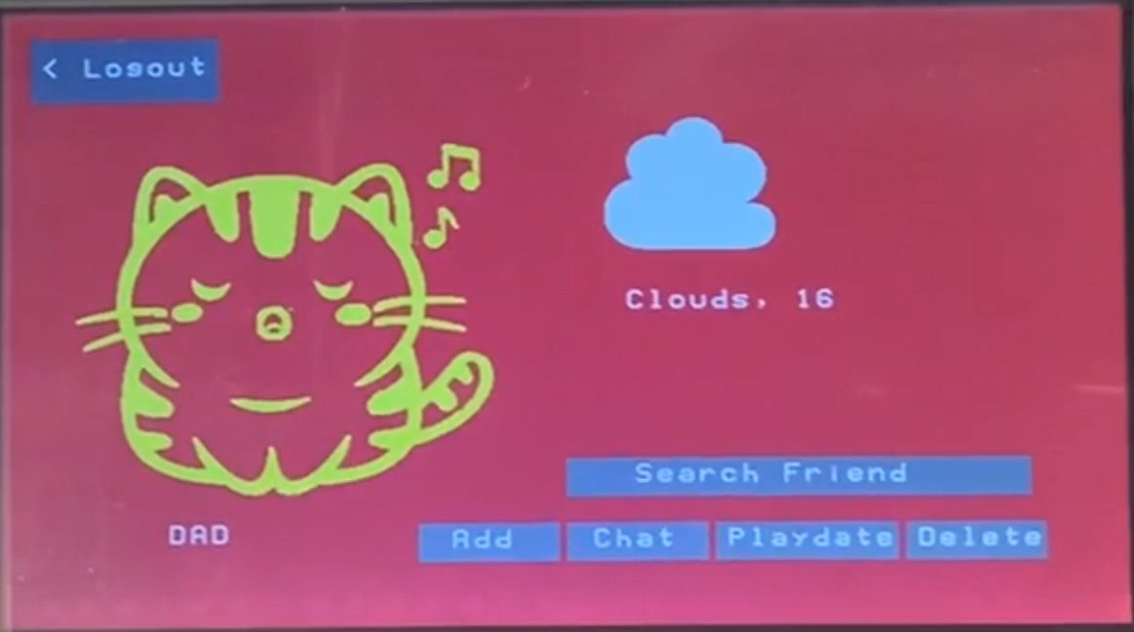

Figure A.4 - Screen of home screen showing singing pet

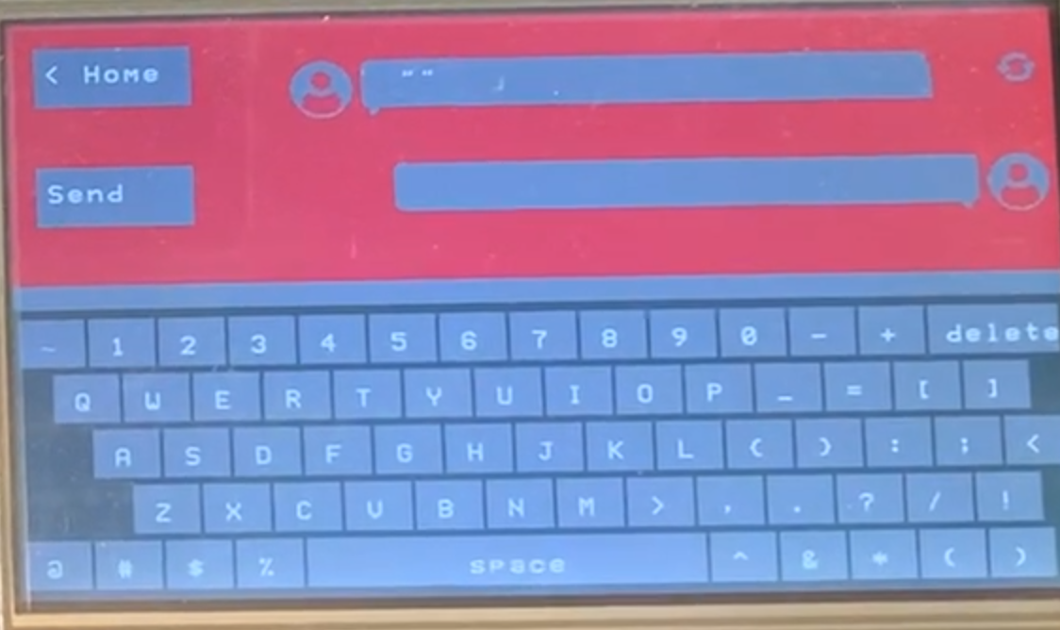

Figure A.5 - Screen of chatroom

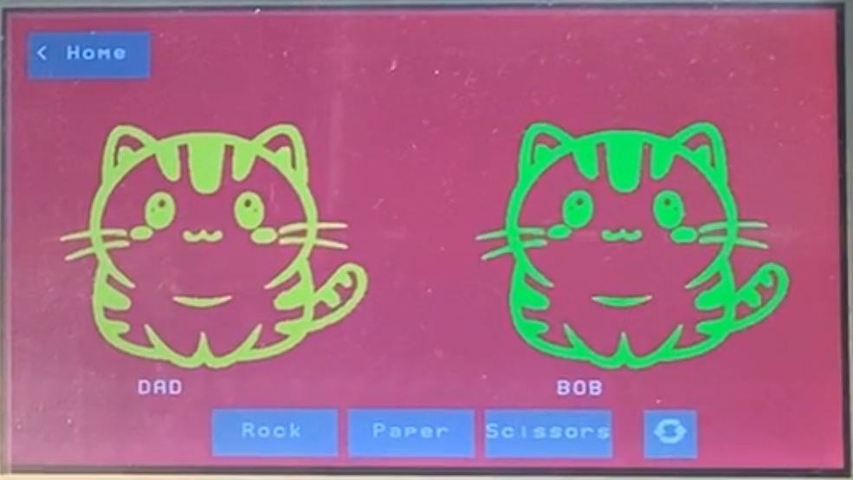

Figure A.6 - Screen of playdate

**Appendix B - Website**

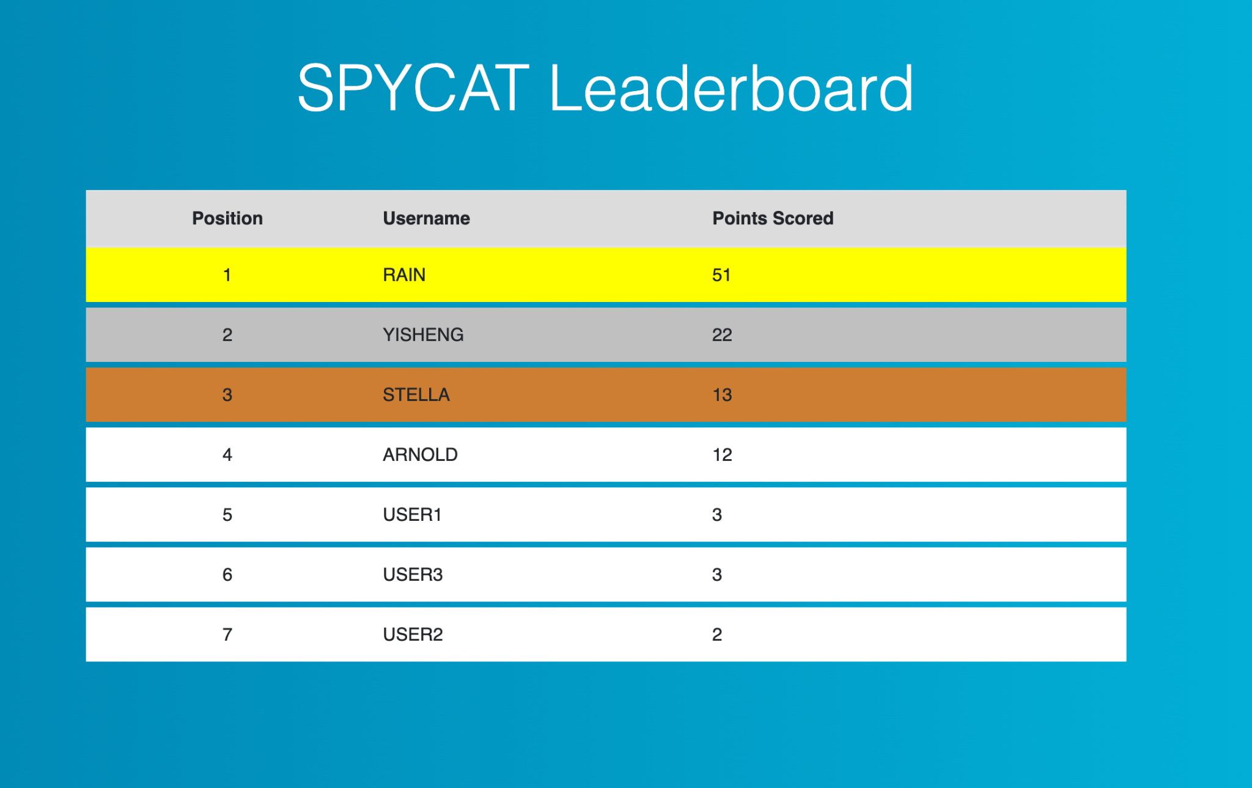

Figure B.1 - Leaderboard website preview

**Appendix C - Schematics**

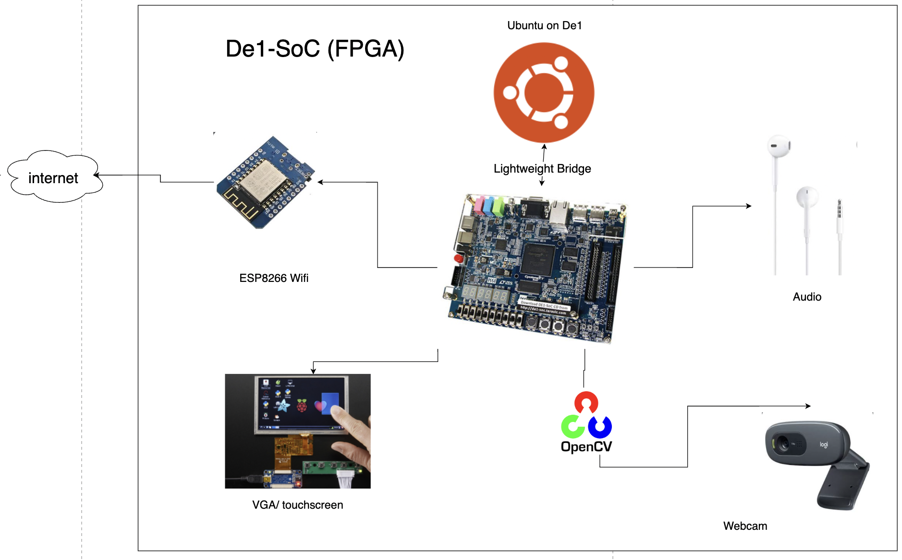

Figure C.1 - Hardware Schematic

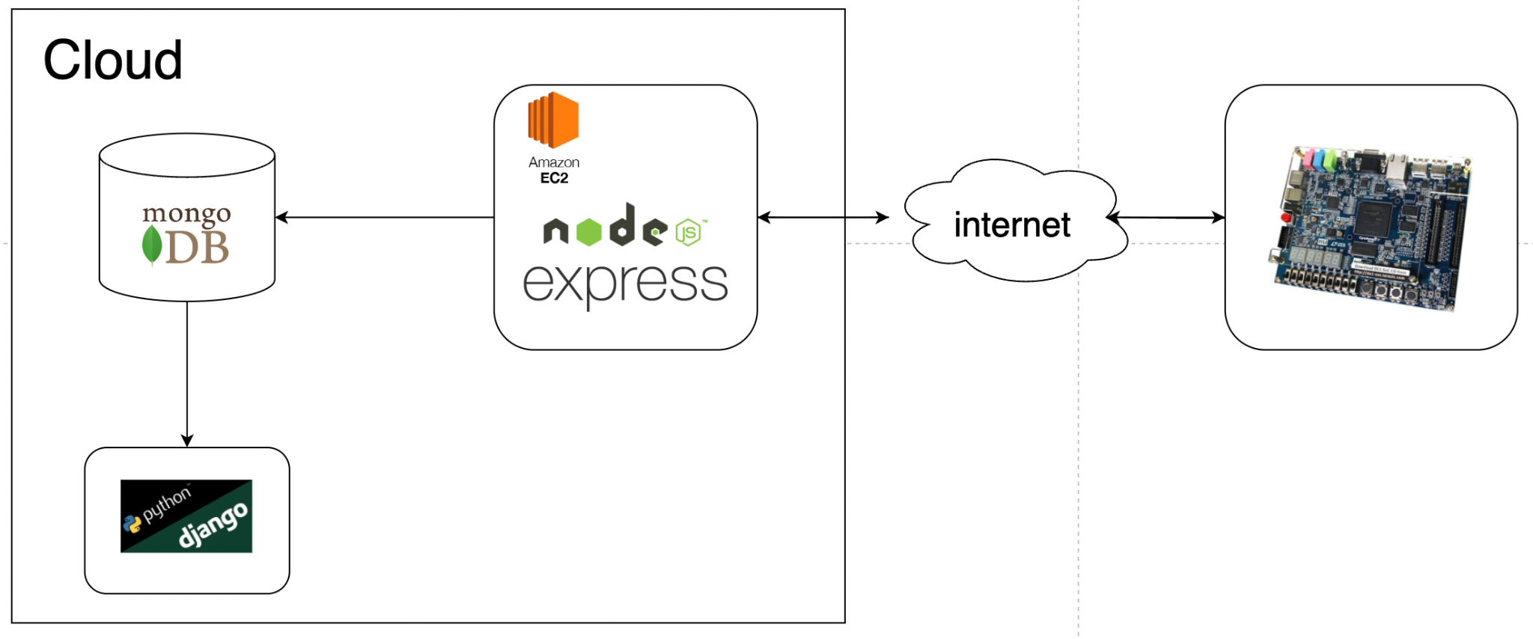

Figure C.1 - Software cloud Schematic

**Appendix D - UI**

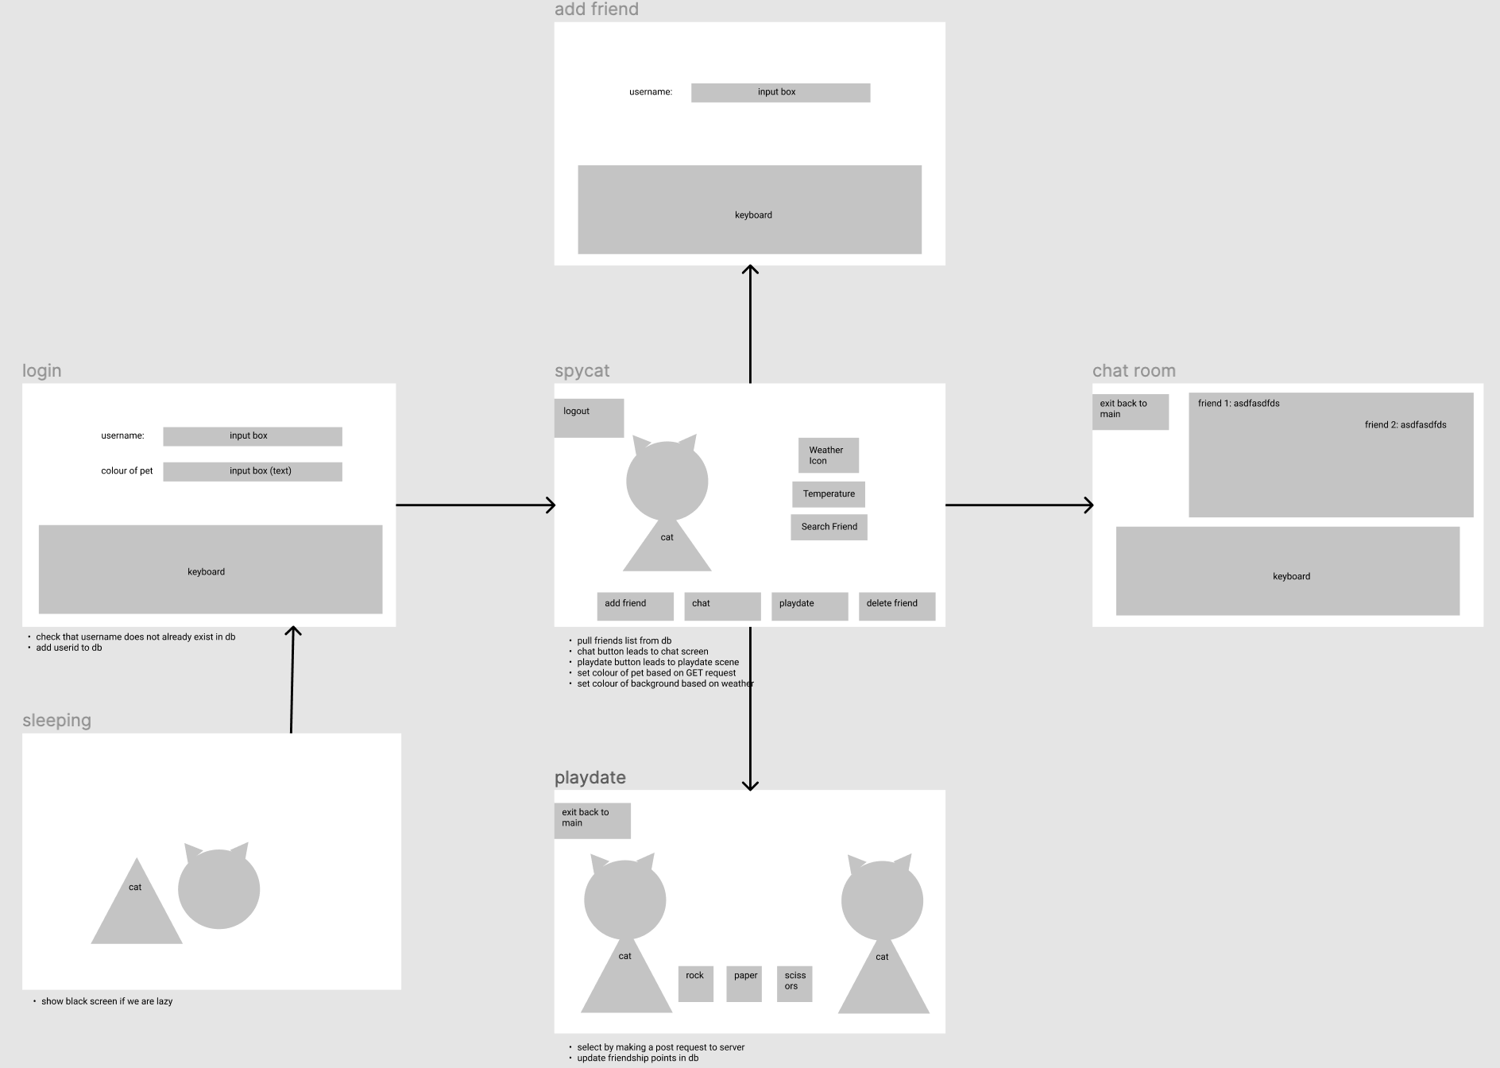

Figure D.1 - Figma layout with various GUI screens and their interactions

**Appendix E - Database**

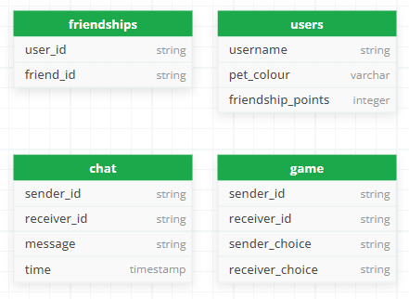

Figure E.1 - Database schematic

**Appendix F - Wifi**

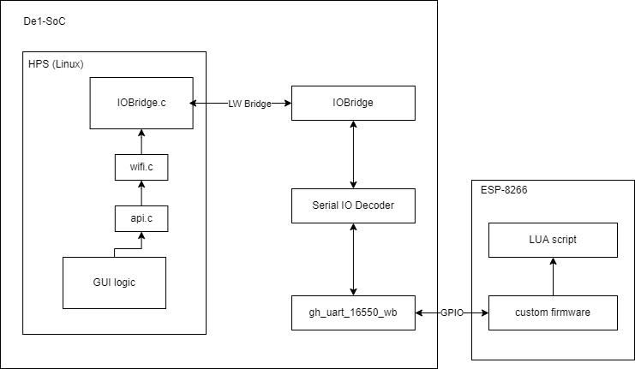

Figure F.1 - Wifi schematic

**Appendix G - USB WebCam**

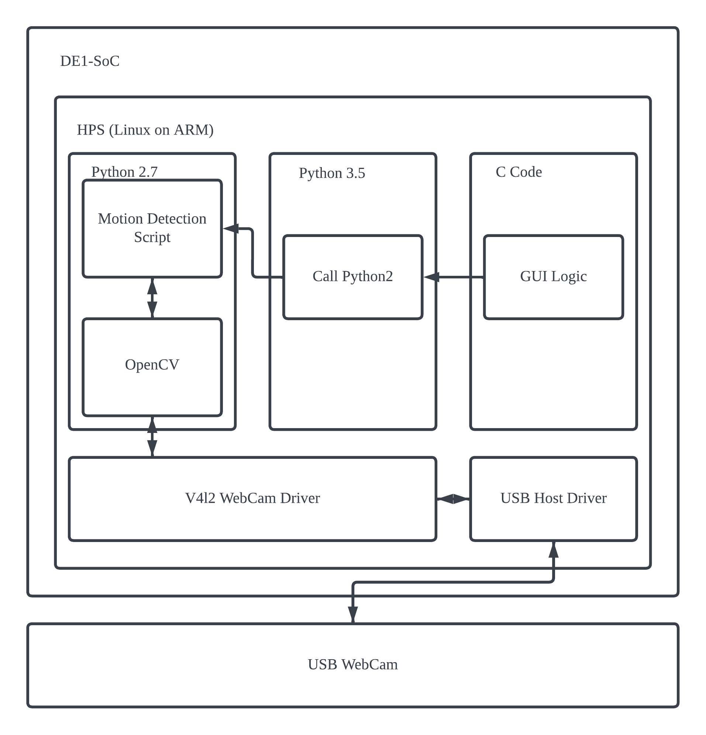

Figure G.1 - USB WebCam call stack